Site: Isleworth Golf & Country Club, Windermere, Florida.

Objective:
Maintain the water quality as well as the aesthetic qualities of Hourglass Lake reservoir as the water recharge transitions from deep well aquifer water to county utility reclaimed water.

Lake Specifics: Hourglass Lake is an eleven acre freshwater lake located within the property boundaries of Isleworth. It is surrounded by two golf course holes to the east, north and west and by seven estate residences along its southern shoreline. For over twenty years this water body has been permitted for golf course irrigation purposes being recharged by deep well aquifer water. Due to the demands for drinking water in the Central Florida area a new consumptive use permit now mandates that the lake must now be recharged by stormwater, reclaimed water and finally deep well aquifer water as a third priority source. This change from a low nutrient content ground water to nutrient rich reclaimed water will cause abrupt changes in the water chemistry of the lake and thereby cause a potential for degradation of the established lake ecosystem and well as a loss in real estate values for the residences that front the waterbody. Early signs of these suspected changes in water quality became evident with the growth of algal blooms in response to the rapid increase in nutrients discharged into the lake as the new permit went into effect.

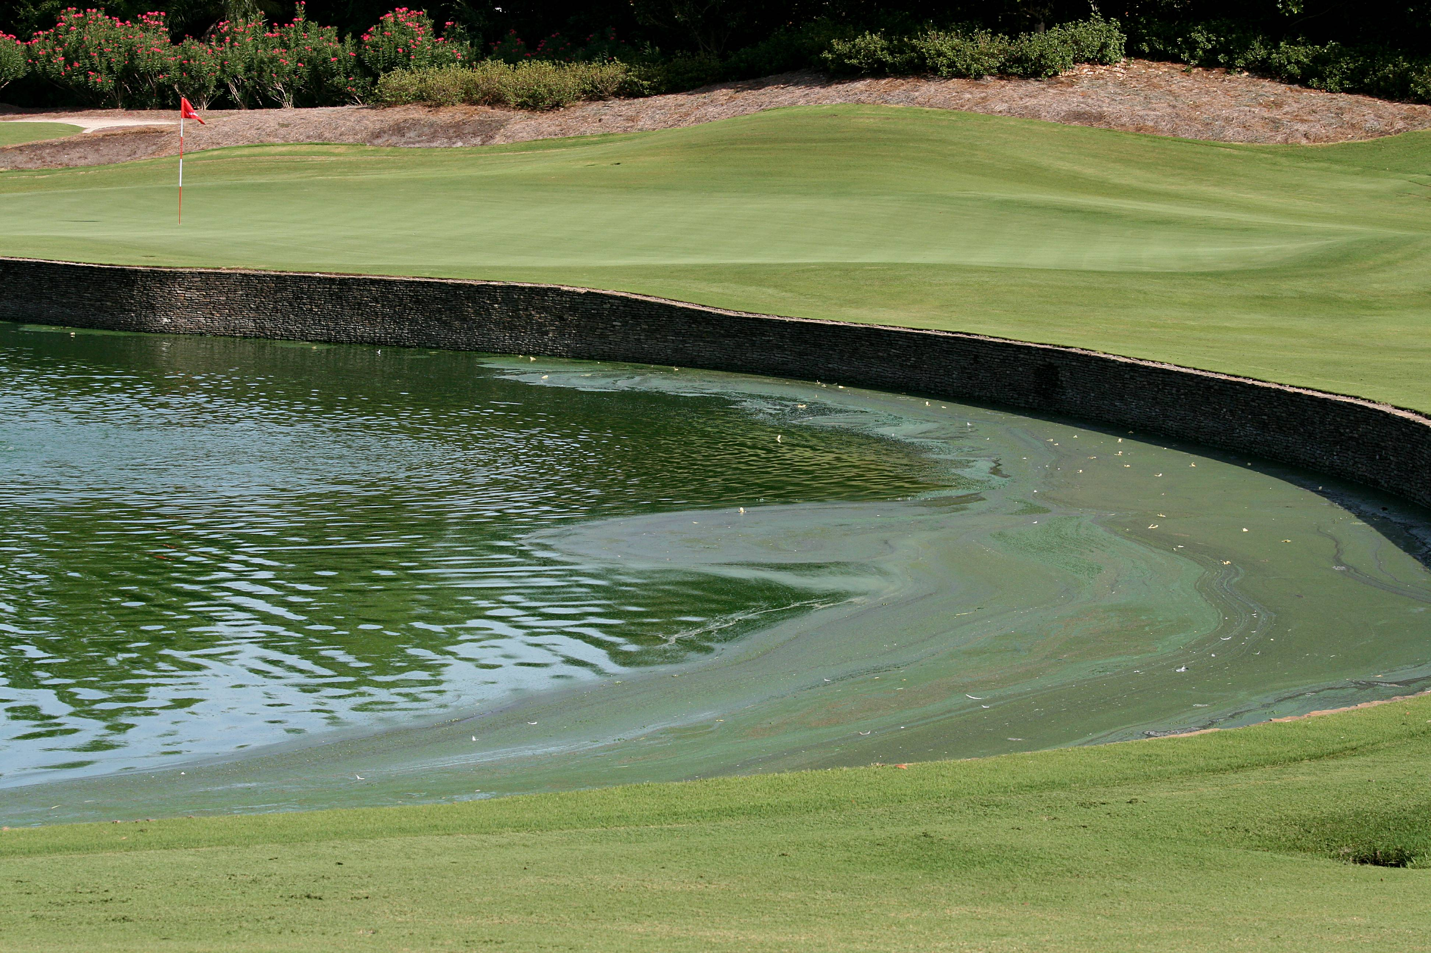

Action Plan: A plan was immediately implemented to utilize bio augmentation products, in this case, Sludge-Away and Microbe-Lift PBL (manufactured by Ecological Laboratories, Inc.) in conjunction with subsurface water mixers to create a biologically active area within the mixing zone of the lake where the reclaimed water is discharged. The intent of the subsurface mixers is to immediately prevent a suitable environment specifically for Blue Green Algal growth by moving the water horizontally throughout the mixing zone and also supplying dissolved oxygen to the pond to support and stimulate the aerobic digestion process created by the addition of the Microbe-Lift PBL blend of bacteria strains. The Sludge-Away microbe formulation is also added to enhance and accelerate the biological performance promoting sediment reduction.

Initial application of 100 gallons of Microbe-Lift PBL and 25 gallons of the Sludge-Away microbe formulation was introduced into the lake. For the next 5 weeks, 25 gallons of Microbe-Lift PBL was applied. A monthly maintenance dosage of 30 gallons of Microbe-Lift PBL is now being applied to Hourglass Lake by injecting the microbes directly into the reclaimed water irrigation line as a pretreatment prior to the water being discharged directly into the lake itself.

RESULTS AND OBSERVATIONS: After two weeks improvement was noticed with a significant improvement in water quality evident within eight weeks. Water clarity was improved along with the elimination of Blue Green algal blooms and the accompanying foul order. A slight sludge reduction was also evident.



After 16 weeks, improvement is pronounced with algal blooms slight and less often and limited to only filament algal species with no foul odors present. Water clarity continues to improve with sludge reduction becoming apparent in the shallow areas along the shoreline. Wildlife values have been preserved as Hourglass Lake serves as a rest stop for migratory birds in the winter months.


The water quality of Hourglass Lake is also monitored from a site specific monitoring well mandated by permit and sampled quarterly by a certified independent water quality laboratory. These seasonal test results indicate over a 90% reduction in nitrates.
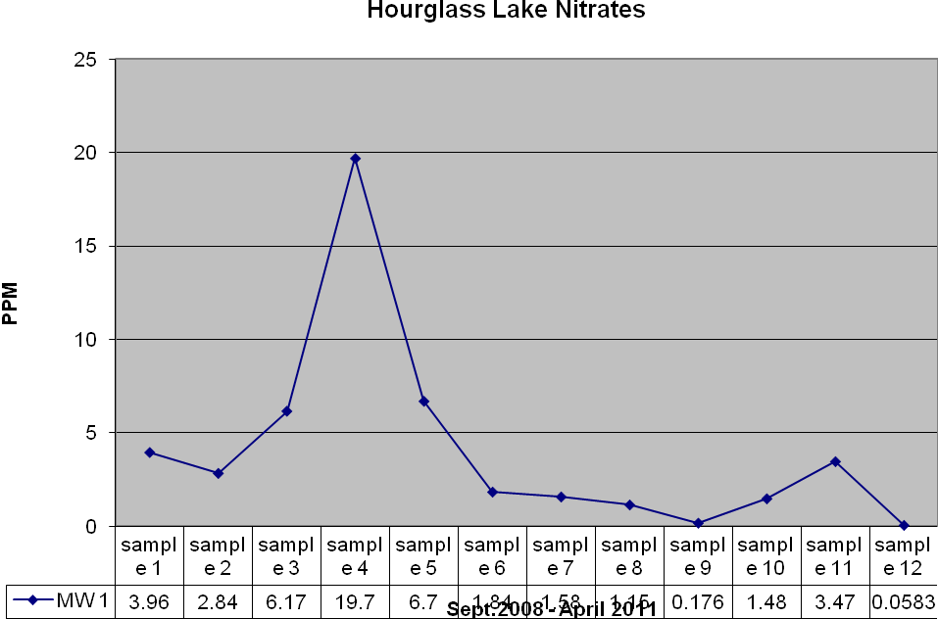
The nitrate spike shown above is the result of fertilizer run-off from the golf course. The rapid reduction in the nitrate level is due to MICROBE-LIFT’s denitrification functions where nitrate is biologically converted to harmless nitrogen gas in a process termed anoxic respiration. MICROBE-LIFT’S cultures assure ongoing nitrate reduction within the lakes environment. The reactions take place in the lakes anaerobic zones (muck) where nitrate is converted to harmless nitrogen gas through anoxic respiration termed denitrification.

MICROBE-LIFT cultures assure continued biological control of excessive nutrient by recycling excessive nitrate to nitrogen gas. This anoxic oxidation process speeds the biological reduction of organic bottom solids and eliminates hydrogen sulfide generation.

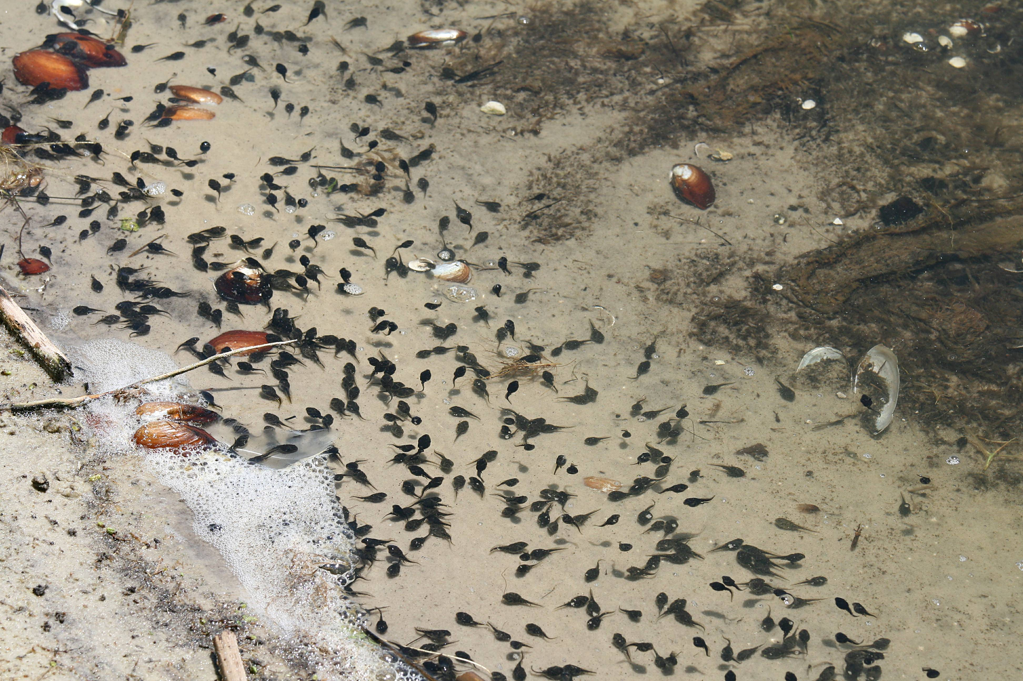

Organic control - Isleworth receives wastewater effluent daily from a wastewater facility to supplement irrigation needs. The effluent contains varying levels of BOD, COD, TSS, and nutrients. Biological augmentation provides control of effluent spikes assuring water quality. The graft indicates the potential negative impact the wastewater effluent represents to the lakes environment, and how important assured biological oxidation is to the lakes environment.
Note the significant COD increase within the lake water as shown in the graft below. Rapid reduction of the COD is assured by MICROBE-LIFT biological oxidation controlling continued influent of BOD, COD, TSS, as well as providing reduction in odorous emissions.
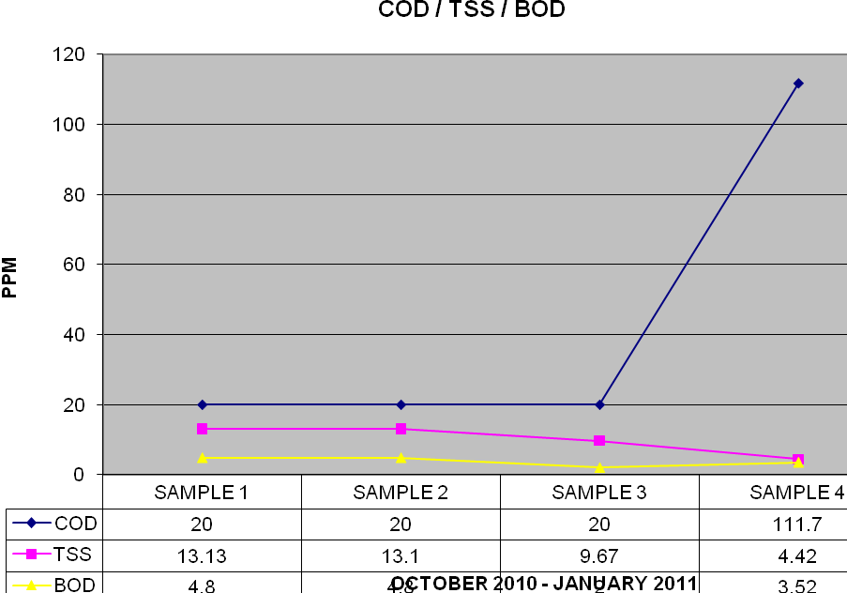

In summary, the lakes overall health and balance has been preserved and enhanced along with its aesthetic appeal for the residents of Isleworth, the synergistic use of aeration and beneficial bioaugmentation has proved to be a valuable tool in preserving this lakes ecosystem



A sustainable environment has now been established for the microbes to thrive and maintain the water quality of Hourglass Lake throughout the seasons of the year fulfilling the needs of the Isleworth golfers, the lake ecosystem and balanced to protect the wildlife that also call Isleworth their home

MICROBE-LIFT cultures assure water quality and provide nutrient control. The augmentation program has proven effective in controlling nitrate levels in the lake and in the test wells located in the area of the lake. The biological augment program has been so effective the augmentation program is now used in several additional lakes at Isleworth.

Submitted by; Isleworth Golf & Country Club, Windermere, Florida.
Ecological Laboratories, Inc
www.microbelift.com
May 19, 2011

